Below is the location in the automotive laboratory, where the linear motors of the active suspension would be tested.

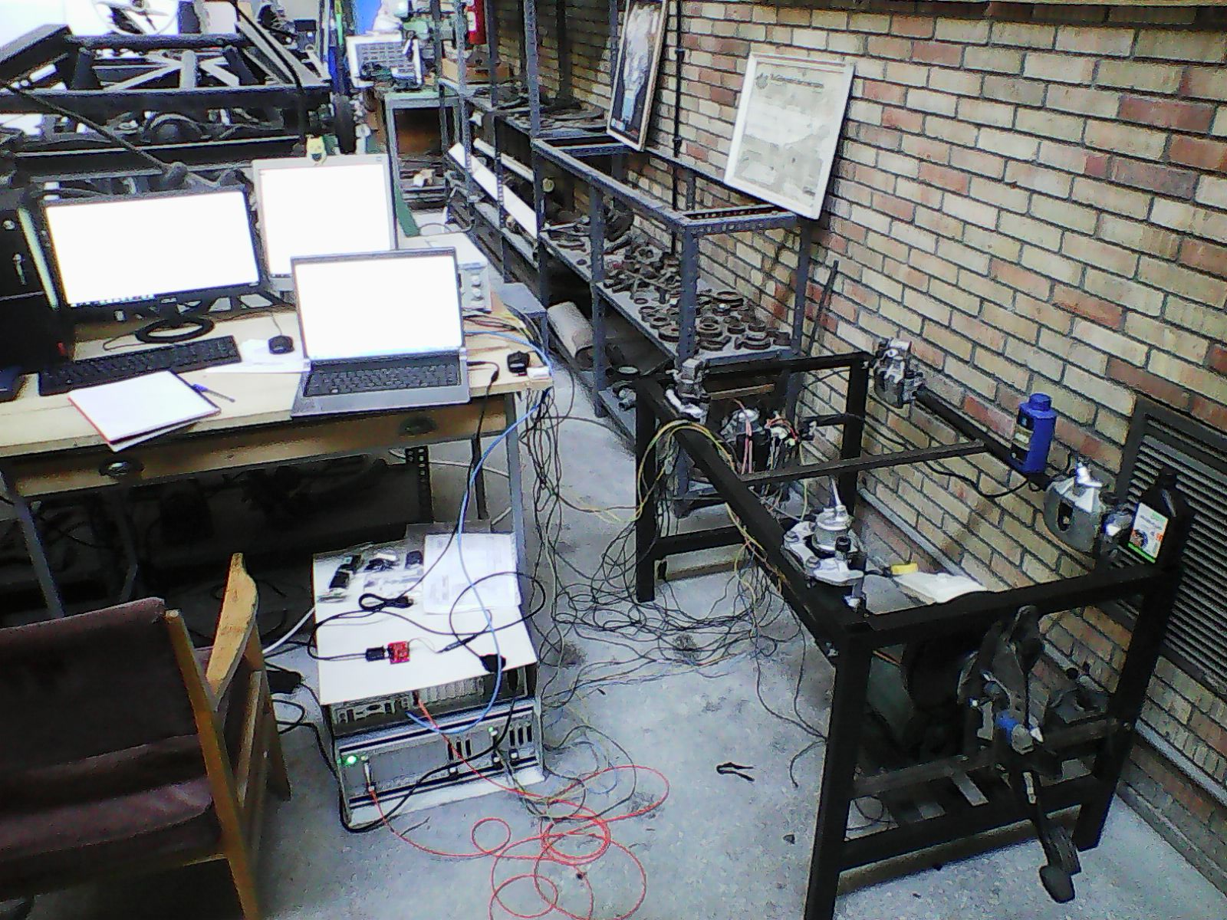

Photograph of the brake Hardware-in-the-loop stand. The components of the stand can be summarized as: 1) Accelerator and brake pedal assembly. 2) Vacuum booster along with the tandem master cylinder, with the hydraulic reservoir mounted at the top. 3) Vacuum pump, run by an electric motor (replacing the crank shaft). 4) Two hydraulic lines between the tandem master cylinder and the ABS module. 5) ABS module. 6) Four hydraulic lines between the ABS module and the calipers. 7) ABS connector and harness. 8) Four wheel speed sensors. 9) Dspace brand Hardware-in-the-loop Simulator. 10) BCM (Body Control Module) 11) Two front, two rear brake calipers.12) Four Kistler brand pressure sensor.

